Text 12

I. summarize each paragraph in one sentence or phrase

|  |  |
| --- | --- |
| Text | Summary |
| Once called the colossus of retailing, Sears filed for bankruptcy on Monday. For the past 25 years, the store that served generations of American shoppers has been unable to compete against big-box chains like Walmart and e-commerce giants like Amazon. |  |
| While the Sears name may yet reemerge in smaller form, its demise offers a cautionary tale – and not just on the need for constant innovation in business. |  |
| While Sears was long a trusted brand name, it never was a vital center in the local communities that it served. Rather, this icon of mass commerce that started in the 1880s will be best known for largely shaping a broad new identity for Americans, one as frequent consumers. |  |
| By 1894, the Sears catalog was 500 pages, reaching millions of Americans. It was a portal into a new universe of material goods, from new styles of clothes to pre-built houses. It was the prime expression of a new type of “consumption community,” according to the late historian Daniel Boorstin. |
| While the Bible was kept in the parlor, the Sears catalog was kept in the kitchen or living room. Boorstin tells the story of a boy who was asked at Sunday school where the Ten Commandments came from and replied that they came from Sears, Roebuck. |
| Later, the Sears stores that invaded American suburbs became an early target among activists who said such chains were eroding the social cohesion of local communities. Sears put many local retailers out of business, thus reducing the everyday interactions of trust and common values that define a community and create a degree of economic self-reliance. |  |
| A local community needs the kind of commerce that builds relationships as much as generates profits. This desire for mutuality between customers and business owners, says philosopher Andreas Weber, is a type of economic culture that is “a practice of love.” |  |
| Many cities and towns today are trying to support local businesses (and farmers) to ensure a rich civic life of connections based on kindness and social bonding. This “local economy” movement is up against the ever-evolving giants of commerce that have come after Sears. Many new outdoor malls, for example, are designed to look like walkable town centers. Yet most of the businesses are national chains. |  |
| At its height, the Sears name defined convenience and low prices. Its bankruptcy filing, however, should also now help define a different approach among national and global retailers, one that sustains local communities rather than using them. | - |

II. What is the issue?

III. Mind-map

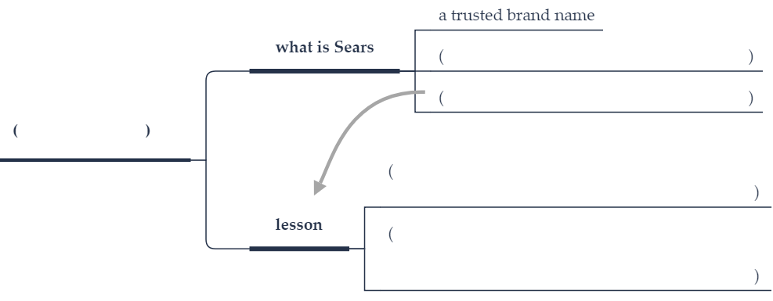

Text 13

I. summarize each paragraph in one sentence or phrase

|  |  |
| --- | --- |
| Text | Summary |
| The huge disruption of air travel at Britain’s second-busiest airport caused by small unmanned flying drones has brought new scrutiny to a growing risk to public safety, privacy, and security. |  |
| The incidents began Dec. 19 and over three days affected more than 1,000 flights and 140,000 passengers, with drones spotted at least 40 times. British authorities remain unsure of the culprit and have offered a reward for helpful information. |  |
| Small flying drones don’t need to carry any kind of explosive or weapon to pose a danger at airports. They could be sucked into a plane’s air intake and cause an engine failure, for example. Police and security teams are reluctant to shoot them down in populated areas because of the risk from stray bullets or the falling drones themselves. |
| Simple drones can cost less than $100 and more sophisticated versions sell online for under $1,000. |  |
| Some 200,000 drones are sold for civilian use around the world every month, according to a study from Oxford Research Group’s remote control project. Nearly a million private drones were registered with the Federal Aviation Administration as of October 2017. |  |
| For years researchers and futurists have theorized about the wonders of a world of drones, perhaps most famously presented in the promise by Amazon CEO Jeff Bezos in 2013 that delivery of packages by drone was only four or five years away. |  |
| That hasn’t happened but unfortunately misuse of private drones has grown: For example, in November a commercial aircraft approaching Boston’s Logan Airport spotted a drone flying just below it, one of a number of reported incidents near airports. |  |
| Drones have also secretly delivered drugs or other illegal items to prison inmates and have been used by a professional soccer team in Germany to spy on a rival club. Drones have even tried to look down on and capture the secretive filming of the popular TV series “Game of Thrones.” |
| While industrial espionage remains a real concern, researchers have considered even more sinister uses. “Think of nearly any worst-case scenario, and you can probably do it with a drone,” says Kunal Jain of the drone security company Dedrone. |
| Tiny drones can be hard to detect and can operate even at night. But defenders are making progress, too. Devices can shoot netting at drones from the ground or from friendly drones to bring them down without resorting to gunfire. Electronic countermeasures can jam GPS or other onboard systems to drop drones from the sky. And in the Netherlands, police are trying a low-tech solution, training eagles to snatch drones with their talons to bring them to earth. |  |
| It seems certain more attention should and will be paid by both government and private industry to counter these tiny intruders before they cause more serious harm. |  |

II. What is the issue?

III. Mind-map

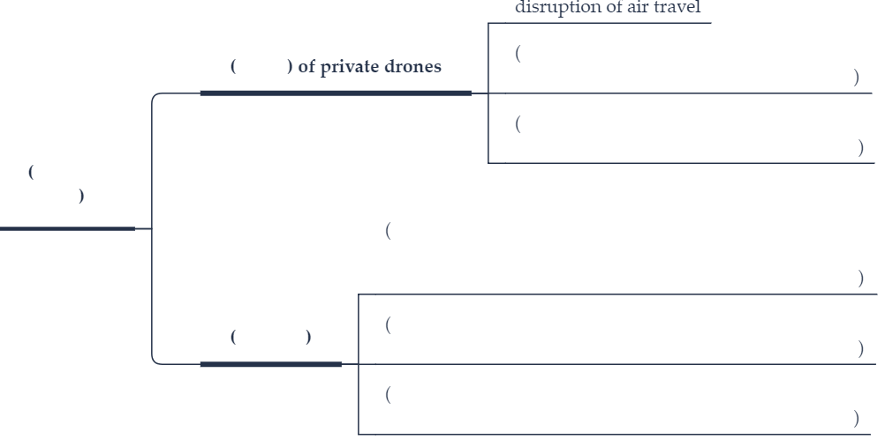

Text 14

I. summarize each paragraph in one sentence or phrase

|  |  |
| --- | --- |
| Text | Summary |
| President Trump has nominated David Malpass, a senior Treasury official and former Wall Street economist, to succeed Jim Yong Kim as next leader of the World Bank. Rather than rubber-stamp the U.S. nomination, as the bank’s other member governments are generally inclined to do, they should ask whether Malpass is the best available candidate — and, even more important, start an open discussion about what the job should entail. |  |
| By longstanding agreement, the U.S. chooses the head of the World Bank, and Europe’s governments choose the head of the International Monetary Fund. Acting together, they’ve been able to exert control. But it’s in the interests of all concerned to find the best qualified leader, and that requires a genuinely competitive process. |  |
| Malpass is coming in for criticism, partly no doubt just because he is Trump’s choice. It’s also true that he’s expressed doubts about globalism in general and the role of multinational institutions in particular. However, for what it’s worth, his experience as a finance professional and high-ranking economic official make him a lot better prepared for the role than his predecessor was. |  |
| What matters more than credentials, though, are the ideas that the next president will bring to the job. The World Bank’s proper role is indeed in doubt. Frequent reorganizations, including the one undertaken by Kim, have been heavy on turmoil, counterattacks, and movement of office furniture, but not so potent when it comes to envisioning what the bank should be doing. |  |
| Malpass has asked whether the bank should continue to lend to China and other non-poor countries, for instance — and that’s a good question. The bank describes China as an “upper middle-income country.” It has $3 trillion in foreign reserves, a handsome surplus of domestic saving over investment, and a far-reaching foreign-lending program of its own. It shouldn’t need to tap a taxpayer-supported development institution for cash. |  |
| This is not just about China. The acute shortage of capital for development that justified the bank’s creation more than 70 years ago no longer exists. Private capital markets can do all the lending the bank was originally designed to do. |
| All this has been well understood for years, if not decades. But the radical remodeling the bank requires still hasn’t happened. The World Bank needs to move away from outdated development lending toward programs to supply global public goods; programs that prioritize knowledge and information over money; and initiatives to improve the lives of the poor in the countries that global markets have left behind. |  |
| None of these ideas are new. Indeed, they are drearily familiar. They need to be recognized as urgent. The process of naming a new World Bank leader should provoke a public debate about ends and means, and demand a detailed plan of action from each of several strong candidates. It’s entirely within the power of the bank’s board to insist on this. | - |

II. What is the issue?

III. Mind-map

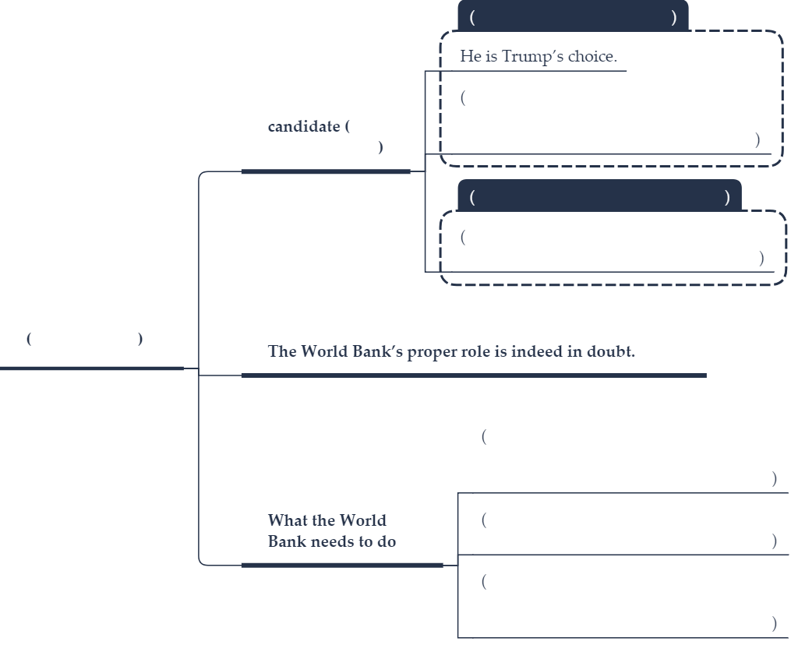

Text 15

I. summarize each paragraph in one sentence or phrase

|  |  |
| --- | --- |
| Text | Summary |
| On Feb. 3, Americans will join in one of their favorite national hobbies, judging TV commercials during the Super Bowl. This year, if one advertisment released early by Gillette is any indicator, the commercials may be more than simply funny. They will be “purpose driven.” | - |
| Gillette’s 30-second “We Believe” commercial calls on more men to prevent harassment of women and to challenge dangerous stereotypes of maleness. It has provoked similar debate as a Nike advertisment last year featuring Colin Kaepernick, the kneeling quarterback. Yet it has yet to fall flat like a recent Pepsi advertisment that was seen as using images of the Black Lives Matter movement only to sell more soda. | - |
| Surveys find corporate leaders increasingly believe they must stand up for a cause. The motive is not only better branding with consumers who want to associate with companies that align with their values. It may also be necessary to attract and retain younger workers. |  |
| More companies face rebellions from employees who disagree with their actions. Last fall, 20,000 Google workers walked off the job for a day to protest the way the company had dealt with cases of sexual misconduct. The demand was clear: You must earn our trust by showing what you stand for, other than making a profit. |  |
| All of this fits into a global trend. In a new survey of 28 countries about the levels of trust around the world, the communications giant Edelman found a profound change from previous surveys: People are putting far more trust in “my employer” to do the right thing in challenging times than they do in other institutions, such as media, government, and social activist groups. And a majority of employees say their employer is a trustworthy source of information about societal issues. |  |
| Another survey done last year of American corporate leaders, found that advocacy by chief executive officers is on the rise. One big reason is to meet employee expectations. |  |
| Today’s C-suite executives must offer more than perks and pay to employees. Sports equipment retailer REI, for example, wants its 12,000 workers to be so close to the environment that it has closed its door on recent Black Fridays so employees can use the day to enjoy the outdoors. |  |
| The Edelman survey hints that more people seek a purpose in life – a calling beyond survival or profit-making. Employers are beginning to heed this desire. And more Americans may see it in the commercials during the 2019 Super Bowl. |  |

II. What is the issue?

III. Mind-map

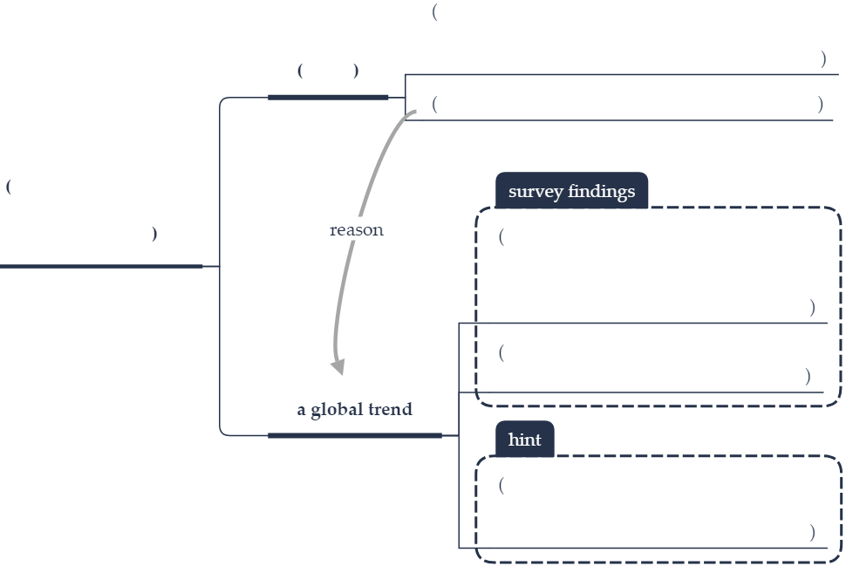

Text 16

I. summarize each paragraph in one sentence or phrase

|  |  |
| --- | --- |
| Text | Summary |
| Politicians across the spectrum are now agreed that the powers of the big tech companies must be curbed. Self-regulation is no longer enough. But it is a long way from sentiment to policy. Monday’s report from the digital, culture, media and sport select committee set out a path. In this work it has had no help from the companies it believes need regulating. |  |
| Facebook, in particular, has shown itself to be arrogant and dishonest. Not only did Mark Zuckerberg refuse to present himself to the committee, the subordinates he sent in his place gave misleading or untrue accounts. |  |
| But the problem is wider than just one company. Google and YouTube, which are hardly mentioned in the report, play almost as important a role in the spreading of misinformation online and are just as happy to profit from it. As the information commissioner, Elizabeth Denham, has warned, we are now being sold political ideas online with the same techniques that are used to sell shoes and holidays. And since the cost of buying into the wrong ideas is much less immediately apparent than the pain of ill-fitting or unfashionable shoes, the political sale is much more easily made. |  |
| In her testimony, the information commissioner put her finger on one of the most important advantages that Facebook has over traditional advertising media. Not only does it know everything its users tell it about themselves; it also compiles “shadow profiles”, which contain all the information that other users and data collectors have supplied about us. Internal emails obtained by the committee show that the company goes to great lengths to acquire such data from its advertisers. These are kept secret from their subjects. Yet Ms. Denham argues that they are personal data and should be brought under the remit of existing privacy regulations. |  |
| There is a paradox at the heart of the extraordinary effectiveness of Facebook and YouTube when it comes to the spreading of ideas. Some people trust what they find there in part because they are so disillusioned with traditional authorities. The online channels, as television did before them, seem to offer an unprecedented intimacy to their users. A smartphone is the friend you take everywhere. But this apparent intimacy is in reality a place where people can be more professionally manipulated than ever before because the advertisers know so much more about us than they could before we entered it. |  |
| Yet this concentration of power offers a paradoxical hope. When a few giant advertising companies control so much of the internet, pressure on them offers governments a means of indirect control over the consumer internet. Governments should never entirely control the internet but we need them there to protect society anyway. |  |

II. What is the issue?

III. Mind-map

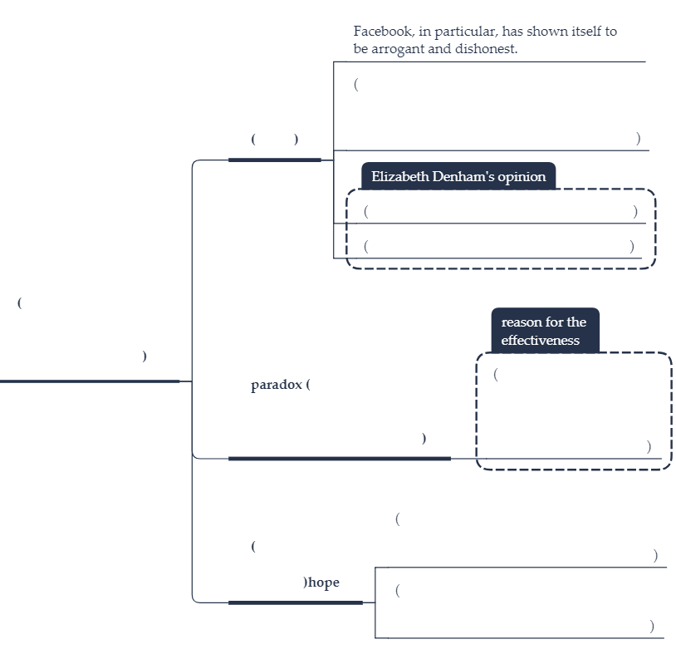

Text 17

I. summarize each paragraph in one sentence or phrase

|  |  |
| --- | --- |
| Text | Summary |
| As it has done for two decades, Fortune magazine has released its annual “100 Best Companies to Work For.” The rankings, based on a survey of some 232,000 employees in the United States, came with few surprises. The top four are Google, Wegmans (food chain), Boston Consulting Group, and Baird (wealth management). What is surprising is how much the top companies are able to nurture trustworthiness in the workplace at a time when levels of trust are falling worldwide. |  |
| Overall, trust in major institutions is at an all-time low, according to a survey of 28 countries last fall by the Edelman communications firm. Trust in government and media has dropped the most over the past 17 years. Trust in businesses has fallen less but hit a low of 52 percent. And last year, the credibility of chief executive officers declined by 12 points to 37 percent. |  |
| Globally, people’s attitudes are still influenced by the 2008 recession and the impact of globalization and automation. More than half said the pace of change in business and industry is moving too fast. | - |
| Such surveys make it doubly important to study companies that do inspire trust. “The best companies are already deeply listening to and strategically acting on insights from their employees, customers, and other stakeholders,” says Edelman CEO Matthew Harrington. |  |
| Here’s a practical reason why a culture of trust can make a difference: The Fortune survey, conducted by the consulting firm Great Place to Work, found that workers who said they experienced a “caring” workplace were 44 percent more likely to be employed by a company with above-average growth in revenue. |  |
| What’s most remarkable is the shift in thinking of employees at the 100 Best Companies. Twenty years ago, 56 percent said promotions go only to those who best deserve them; now the figure is 79 percent. Only 66 percent used to think every worker had an opportunity to get special recognition; now 84 percent do. And only 55 percent once thought managers avoided playing favorites; now 74 percent do. Companies on the list experience half the turnover rate as their industry peers. |  |
| For sure, trust can be won with benefits. The top 100 are noted for their on-site childcare, paid time-off to volunteer, job sharing, or tuition reimbursement. But more important may be the intangible qualities that bring out the best in human behavior, such as respect, transparency, integrity, and authenticity. |  |
| With trust so low in other institutions, especially government, businesses can be part of the solution if they engage fairly and honestly with workers. A firm’s reputation still depends on the quality of its products or services but, more so than in the past, so do the qualities of management toward workers that build trust. Those that win over their employees might even make the next list of “best companies to work for.” |  |

II. What is the issue?

III. Mind-map

